Application of seismic inversion constrained geological modeling technology in quantitative characterization of thin reservoirs

Zhang Yongshou 1, Ma Peiling1, Yin Ning1, Yang xiaochuan1, Han Yaozu1, Luo Wei1

1 Korla Branch of Geophysical Research Institute, BGP, CNPC, Korla 841001, China

1406176342@qq.com

Abstract：With the gradual deepening of petroleum exploration and development, the scale of reservoir research in oil and gas reservoirs is getting smaller and smaller, and the demand for accuracy is getting higher and higher.During the development of clastic reservoirs in the Tarim Basin,the lithology of reservoir sand bodies changes rapidly and the lateral continuity is poor,so it is difficult to effectively identify the space distribution of sand bodies by relying solely on geological logging data.In this study, combined with the advantages of logging curve for vertical identification of sand bodies and seismic data for horizontal distribution identification of reservoirs, the seismic inversion constrained geological modeling technology is proposed to realize the quantitative characterization of thin reservoir sand bodies in developed oil and gas reservoirs : ①Through the analysis of sensitive characteristic curve and the extraction of targeted seismic plane attributes, the feasibility evaluation of inversion in the target area is completed, and the seismic inversion results of thin reservoirs are generated.②Based on the results of seismic inversion simulation, a high-precision 3D lithofacies geological model is constructed by analyzing the applicability of stochastic modeling method. ③ Combined with geological cognition, the physical property characterization of 3D lithofacies geological model is realized by physical property truncated simulation method, and the spatial distribution pattern of effective sand bodies is depicted.Through the application of this method in the study area A, the problem of certain deviation between reservoir inversion driven by conventional frame model and geological cognition is solved. While the spatial recognition ability of sand bodies is further improved, the quantitative characterization of thin reservoir

1

physical properties is realized, which provides effective technical support for the subsequent development of oil and gas reservoirs.

Keywords : thin sand reservoir ; seismic inversion, geological modeling, quantitative characterization

Introduction
Thin sand reservoir has always been the focus and difficulty of clastic reservoir prediction. It has the characteristics of rapid lateral variation of lithofacies and thin sand body ( generally 1
~ 5m ). Limited by seismic resolution, conventional seismic inversion methods are difficult to describe the distribution pattern and spatial distribution characteristics of reservoirs, which cannot meet the needs of oilfield production[1]. Seismic constrained geological modeling technology is based on geostatistics theory as the core, the well data ( logging data, drilling data, etc. ) as hard data constraints, the seismic information ( conventional seismic interpretation data, seismic inversion data and seismic attributes, etc. ) as soft data constraints, so as to establish a geological model method. This method is a reservoir prediction technique that combines deterministic modeling with stochastic modeling. It gives full play to the number of seismic and reduces the uncertainty of the model. It is an effective method to solve the prediction of thin reservoirs[2].

In this paper, X oilfield is taken as an example. Its structural situation is located in the western end of Tazhong No.4 structural belt in Tazhong central fault anticline belt of central uplift belt of Tarim Basin.The target layer of this study is the thin sand reservoir in the lower mudstone section of carboniferous.The sedimentary environment is tidal flat facies, mainly developed sand flat and mixed flat.The lithofacies are dominated by siltstone, with an average porosity of 11.5 % and a permeability of 15.65 × 10-3μm2.It belongs to low porosity and low permeability reservoir.A total of 8 wells were drilled in the study area, of which 6 were drilled in the thin sand reservoir of the lower mudstone section, and the thickness of the sand was 1 to 1.5 meters. In this paper, the seismic inversion results are introduced into the simulation of three-dimensional geological modeling as variables, so as to improve the prediction accuracy of thin reservoirs.

logging constrained inversion
Logging constrained inversion is an organic combination of logging and seismic, which gives full play to the advantages of high vertical resolution of logging and breaks through the limitation of seismic resolution.On the basis of seismic data deconvolution processing, wavelet is extracted for horizon calibration, and then a high-precision wave impedance model is established[3,4].Considering the actual situation of the study area, according to the prediction needs, the natural gamma model is randomly inverted, and finally the inversion model that conforms to the sedimentary law of the area is selected after verification.

The extraction of seismic wavelet is the key to the accuracy of seismic inversion. The Ricker wavelet and the logging wave impedance curve are selected to generate a synthetic record, and the synthetic record is matched with the seismic reflection to ensure that the inversion

result has the same frequency and phase characteristics as the seismic. On the basis of horizon calibration, according to the sedimentary model and fault space combination relationship in the study area, the wave impedance model is established in combination with the calibration well.

The seismic inversion target needs to be closely related to seismic data and logging data in order to effectively combine the two types of data. The analysis shows that the natural gamma curve of X oilfield has a good correlation with the wave impedance curve, and the natural gamma is also one of the important parameters of reservoir characterization. Therefore, the natural gamma curve is the best target of seismic inversion.In this paper, random inversion is adopted. This method gives more play to the characteristics of high vertical resolution of logging data, and has obvious advantages for sand reservoir inversion.

Random inversion can achieve multiple goals at the same time. The well profiles of 6 key wells such as X8, X4 and X3 are selected, and the logging data of each well are used to verify. Finally, the most consistent implementation is selected as the inversion result (Fig.1).The seismic inversion model reveals that a set of thin sand reservoir is developed in the large set of mudstone in the lower mudstone section.The sand characteristics are clear, and the thinning-out point is clear.
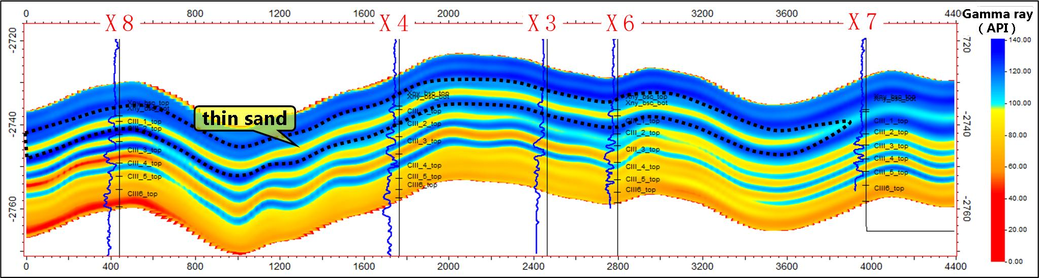
Figure 1. The east-west natural gamma seismic inversion profile of X8-X4-X3-X6-X7 well

3D geological modeling
3D geological modeling is another effective method for reservoir prediction, which can more intuitively and comprehensively characterize the distribution and variation of reservoir physical parameters in space[5].For thin sand reservoirs, due to the characteristics of rapid change of lithofacies and poor lateral continuity of reservoir sand, facies-controlled modeling can be used to realize the spatial characterization of thin sand reservoirs.

The process of facies-controlled modeling of thin sand reservoir is as follows : Firstly, the single well horizon and breakpoint data are used as the control data, and the three-dimensional structural model is established by using the constraint of seismic structural interpretation results.

Then, the lithofacies model under seismic constraint is established. On this basis, the variation function is obtained by single sand layer and different lithofacies. The seismic inversion attribute of wave impedance is used as the synergistic variable, and the 3D reservoir

parameter model is established by facies constraint. Finally, according to the physical characteristics of the reservoir, combined with the actual drilling situation on the well, the distribution range of favorable targets is depicted.
  - Construction model establishment
The structural model is the basis of the attribute model, and its accuracy directly affects the accuracy of reservoir prediction[5,6].Due to the lack of fracture development in the reservoir area, structural modeling only needs to complete the layer model.
In this paper, the single well layered data is used as the control point, and the top surface of the thin sand layer in the lower mudstone section of the seismic interpretation is used as the trend surface constraint. The model of each small layer is established by the moving average interpolation method, so as to complete the establishment of the 3D structural model(Fig.2).In order to achieve the purpose of accurate description of reservoir distribution and quantitative characterization of reservoir, according to the characteristics of thin sand reservoir, combined with the area of the study area and the average thickness of each layer in the area, in the process of constructing the model grid, the plane grid adopts a grid step of 20m × 20m.Due to the thin thickness of the thin sand reservoir, the vertical grid of the thin sand reservoir is divided by an average thickness of 0.1m, and the vertical grid of the other layers is divided by an average thickness of 0.5m to establish the model grid. Through the method of encrypting the grid in the key layer, the fine characterization of the thin sand layer is ensured to the greatest extent and the number of operations is reduced, which greatly reduces the time cost.
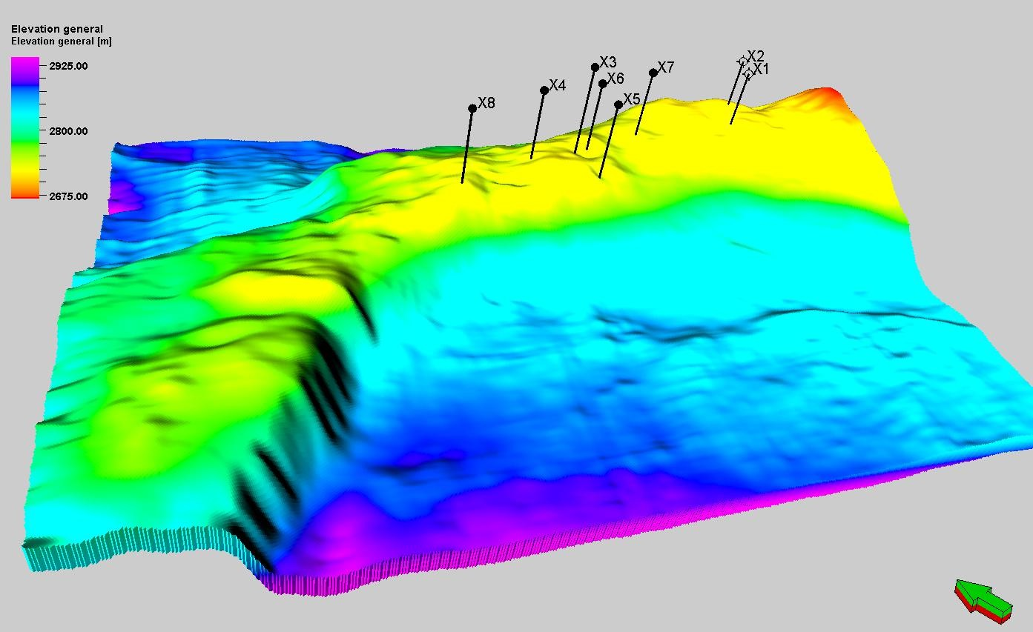
Figure 2. 3D structural model of the lower mudstone section of carboniferous in X oilfield

  - Attribute model
Compared with the conventional modeling method, the attribute modeling established under the seismic constraint greatly eliminates the uncertainty between wells by using the characteristics of good lateral continuity of seismic, which is of great significance to the accuracy of modeling results[7,8]. This attribute modeling is mainly divided into two steps : ① Based on the conclusion of logging interpretation, the lithofacies model is established under the constraint of seismic inversion. ②Under the constraint of lithofacies model, the porosity and permeability models are established by single layer and lithology.

In stochastic modeling, the sequential Gaussian method based on pixel-based simulation can simulate both continuous data and discrete data, and ensure the accuracy of well point data while reducing cross-well uncertainty.
    - Data correlation analysis
A key parameter for establishing a 3D attribute model is the correlation coefficient between logging data and seismic data. The correlation coefficient determines the feasibility of multi-parameter collaborative modeling. The results of previous studies have shown that when the correlation coefficient between the main variable and the dependent variable is greater than 0.4, it can play an effective spatial constraint and indication role in the prediction results[9]. In this paper, the correlation between logging natural gamma parameters and seismic inversion natural gamma parameters of all drilled wells in X oilfield is analyzed by crossplot method. The correlation coefficient between the two is about 0.72, indicating that there is a good correlation between them(Fig.3). The natural gamma data volume of seismic inversion can be used as a synergistic variable to participate in the simulation of 3D natural gamma attribute model.
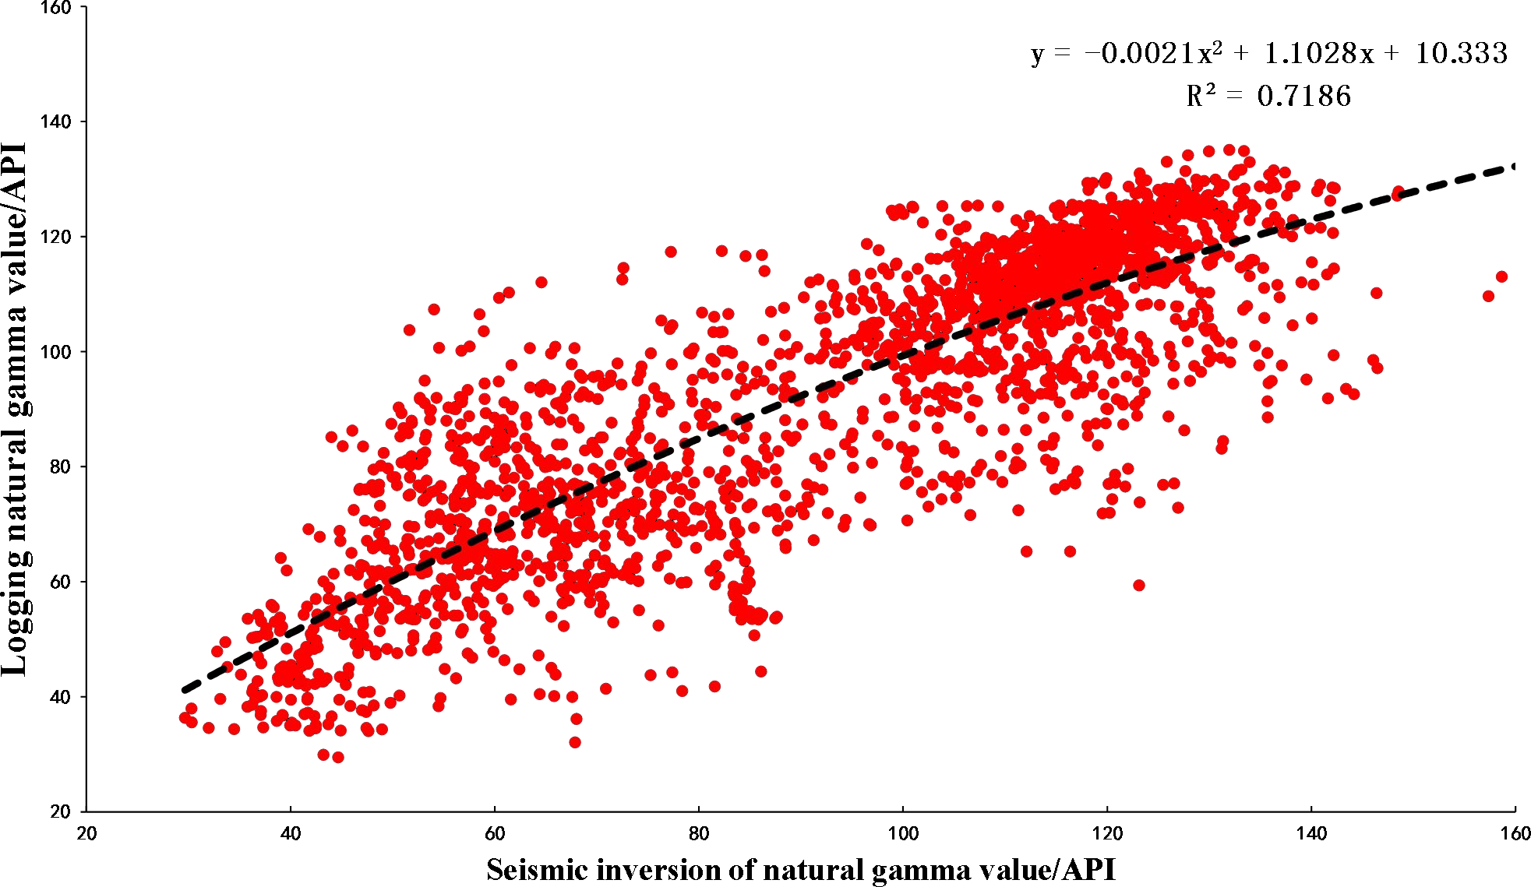

Figure 3. Logging natural gamma and seismic inversion natural gamma crossplot

    - Variation function analysis
Variation function is an important parameter in stochastic simulation, which reflects the characteristics that the degree of spatial variation varies with distance. The variation function in different directions can reflect the variation characteristics of variables in different directions. If the variation diagram in each direction is basically the same, it is isotropic, otherwise it is anisotropic. In most sedimentary environments, the correlation of geological variables is different in different directions, so the actual variables are basically anisotropic. On the plane, the range along the main stream line is greater than that in the vertical mainstream direction ; because the lateral scale of the geological body is much larger than the vertical direction, the vertical range is often much smaller than the plane in all directions. On the plane, the anisotropy can be represented by an ellipse, and the long axis direction indicates the mainstream direction, that is, the source direction. The length of the long axis represents the main range, and the length of the short axis represents the secondary range(Fig.4) ^{[10,11]}.

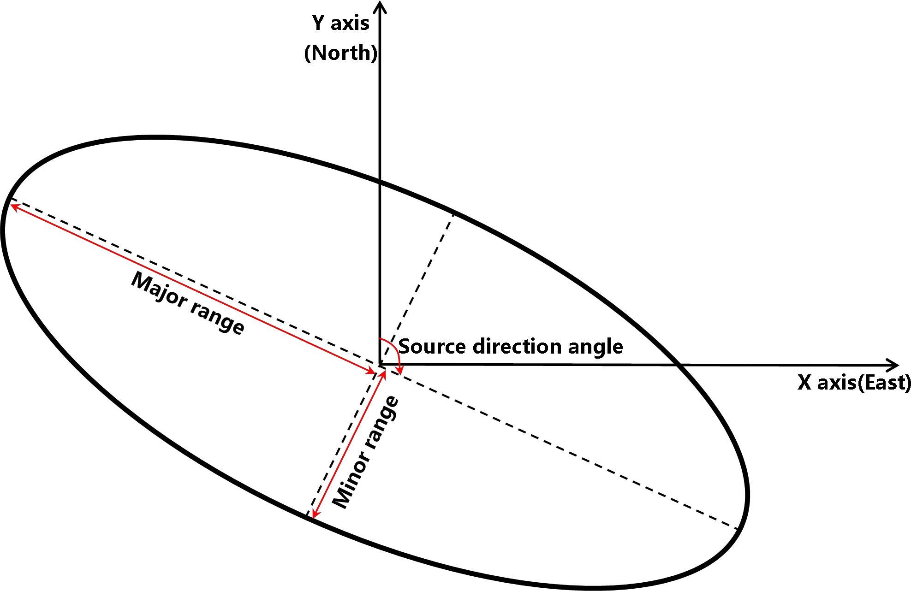
Figure 4. A schematic diagram of geometric anisotropy ( according to Deutsch, 1992 )

    - Seismic constraint Establish lithofacies model
On the basis of data analysis, logging data and seismic inversion data are used as macro constraints under hard control conditions and soft control conditions, and the correlation coefficient between them is used as a synergistic factor. Under the control of structural model, sequential Gaussian synergistic simulation method is used to simulate the lithofacies of thin sand reservoir in lower mudstone section of A oilfield. Analysis and comparison of geological modeling and seismic inversion results : The overall trend is basically the same, but the lithofacies geological modeling depicts the sand body more carefully, clearly depicts the vertical superposition relationship and lateral pinch-out phenomenon of the thin sand body, and the degree of agreement with the reservoir characteristics of the well point is improved(Fig.5). The results of lithofacies modeling have more seismic constraints between wells, which reduces the uncertainty and multiplicity of sand body distribution and improves the prediction accuracy of sand body between wells.
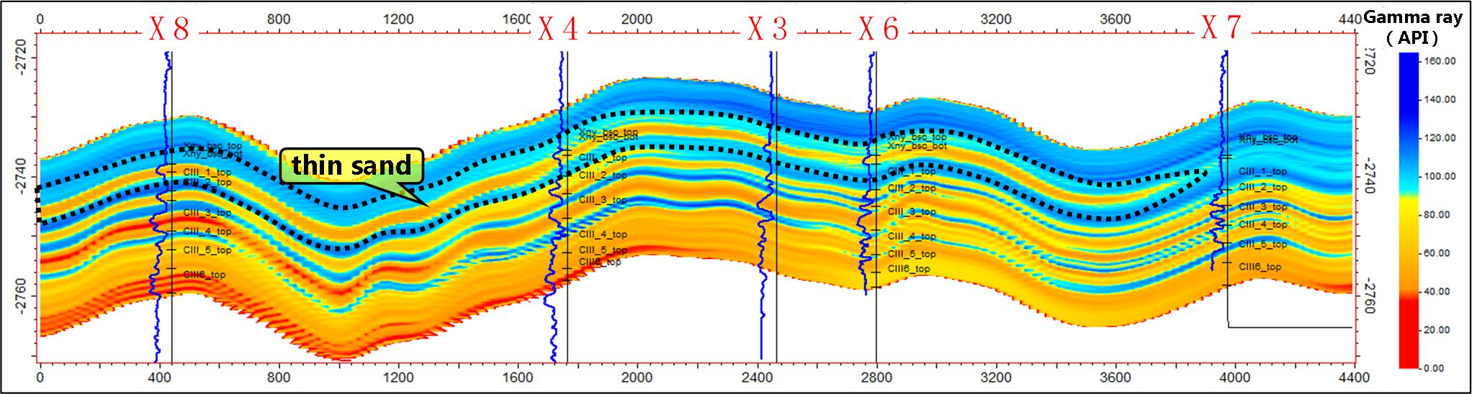
Figure 5. The east-west natural gamma geological model profile of X8-X4-X3-X6-X7 well

    - Phase-controlled constraint to establish physical property model
Porosity is one of the most basic rock physical properties. Determining the pore distribution of the reservoir is a necessary step to describe the pore space of the underground formation. Usually, before modeling other rock physical parameters, the distribution characteristics of rock porosity are simulated first, because porosity can be constrained by many data, while

other rock physical properties, such as fluid saturation and permeability, are often related to porosity. At this time, other rock physical parameter models can be established with porosity model constraints[12]. This porosity modeling applies the idea of phase-controlled parameter modeling. According to the ' two-step modeling ' method, the seismic inversion data is used as the second variable, and the lithofacies model is coordinated. The porosity model is established by using the phase-controlled sequential Gaussian simulation method and layered lithofacies constraints. The permeability simulation is similar to the porosity model. The difference is that the second variable is no longer the seismic inversion data, but the established porosity model. The simulation results can be seen : The general trend of the physical property model is basically consistent with the lithology distribution, and the physical property model also reflects the heterogeneity within the sand body. And the model shows the distribution characteristics of reservoir physical properties in 3D space, which lays a foundation for determining the reservoir dessert area and fine calculation of reserves(Fig.6, Fig.7).
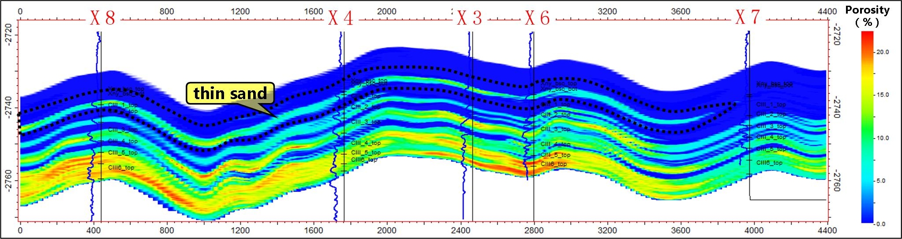
Figure6. The east-west porosity geological model profile of X8-X4-X3-X6-X7 well
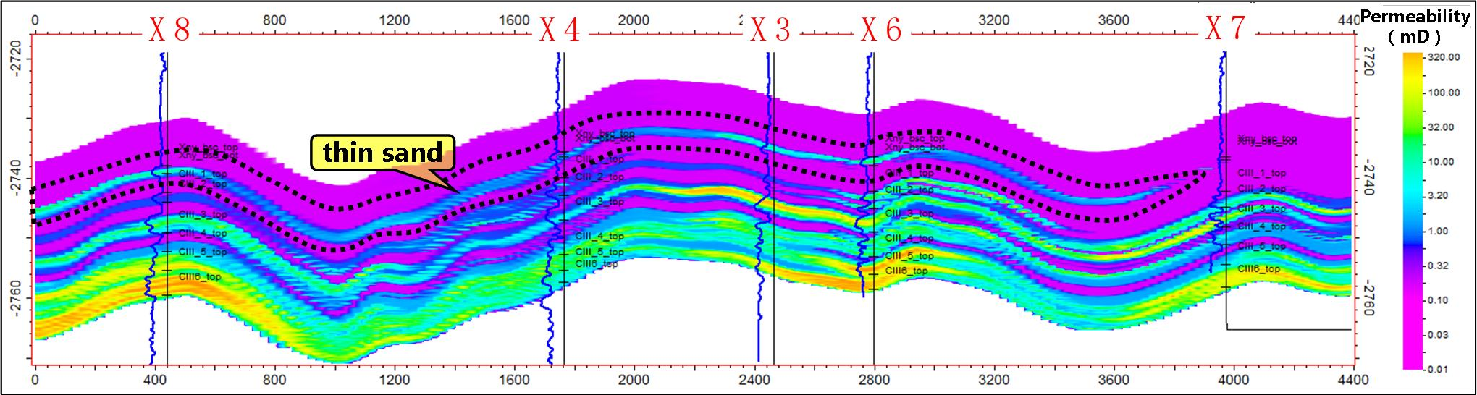
Figure7. The east-west permeability geological model profile of X8-X4-X3-X6-X7 well

trap characterization
Through seismic constrained geological modeling technology, the distribution range and distribution characteristics of sand bodies in the lower mudstone section are finely implemented. At the same time, on the basis of facies control, the physical properties of sand bodies are quantitatively described. Finally, lithologic traps are characterized in the thin sand reservoir of the lower mudstone section of X oilfield. The area is 25.3km2, the porosity of the sand is 7.5 ~ 14.1 %, and the permeability is 5mD ~ 50mD.

Summary
The combination of seismic inversion technology and 3D geological modeling technology is

an effective means to improve reservoir prediction and provides a new research idea for later reservoir description.Based on the results of seismic inversion, a fine 3D geological model is established, which is a further improvement of reservoir prediction technology. The prediction results describe the sand body more accurately than the inversion data, the vertical resolution is higher, and the predicted reservoir distribution is more accurate.

